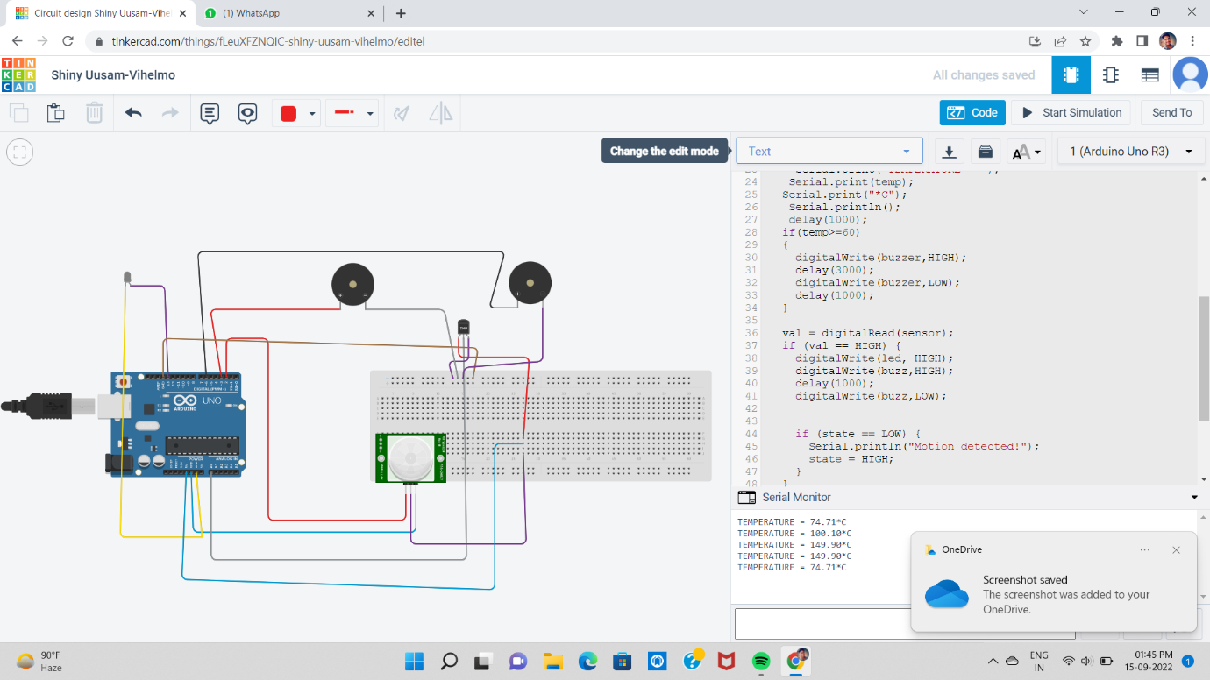

nt led = 13;

int sensor = 2;

int state = LOW;

int val = 0;

const int buzzer = 3;

const int buzz = 6;

float temp;

int tempPin = 0;

void setup() {

pinMode(led, OUTPUT);

pinMode(sensor, INPUT);

pinMode (buzzer, OUTPUT);

pinMode (buzz, OUTPUT);

Serial.begin(9600); }

void loop(){

temp = analogRead(tempPin);

temp = temp \* 0.48828125;

Serial.print("TEMPERATURE = ");

Serial.print(temp);

Serial.print("\*C");

Serial.println();

delay(1000);

if(temp>=60)

{

digitalWrite(buzzer,HIGH);

delay(3000);

digitalWrite(buzzer,LOW);

delay(1000);

}

val = digitalRead(sensor);

if (val == HIGH) {

digitalWrite(led, HIGH);

digitalWrite(buzz,HIGH);

delay(1000);

digitalWrite(buzz,LOW);

if (state == LOW) {

Serial.println("Motion detected!");

state = HIGH;

}

}

else {

digitalWrite(led, LOW);

delay(500);

if (state == HIGH){

Serial.println("Motion stopped!");

state = LOW;

}

}

}